Balance
# Source: AI Source: Provided by: [Data Path: Persons Table -> ID Column: 1, Name_En Column: Motasem Essam] -> From: [ChatGPT] on [7/17/2026]
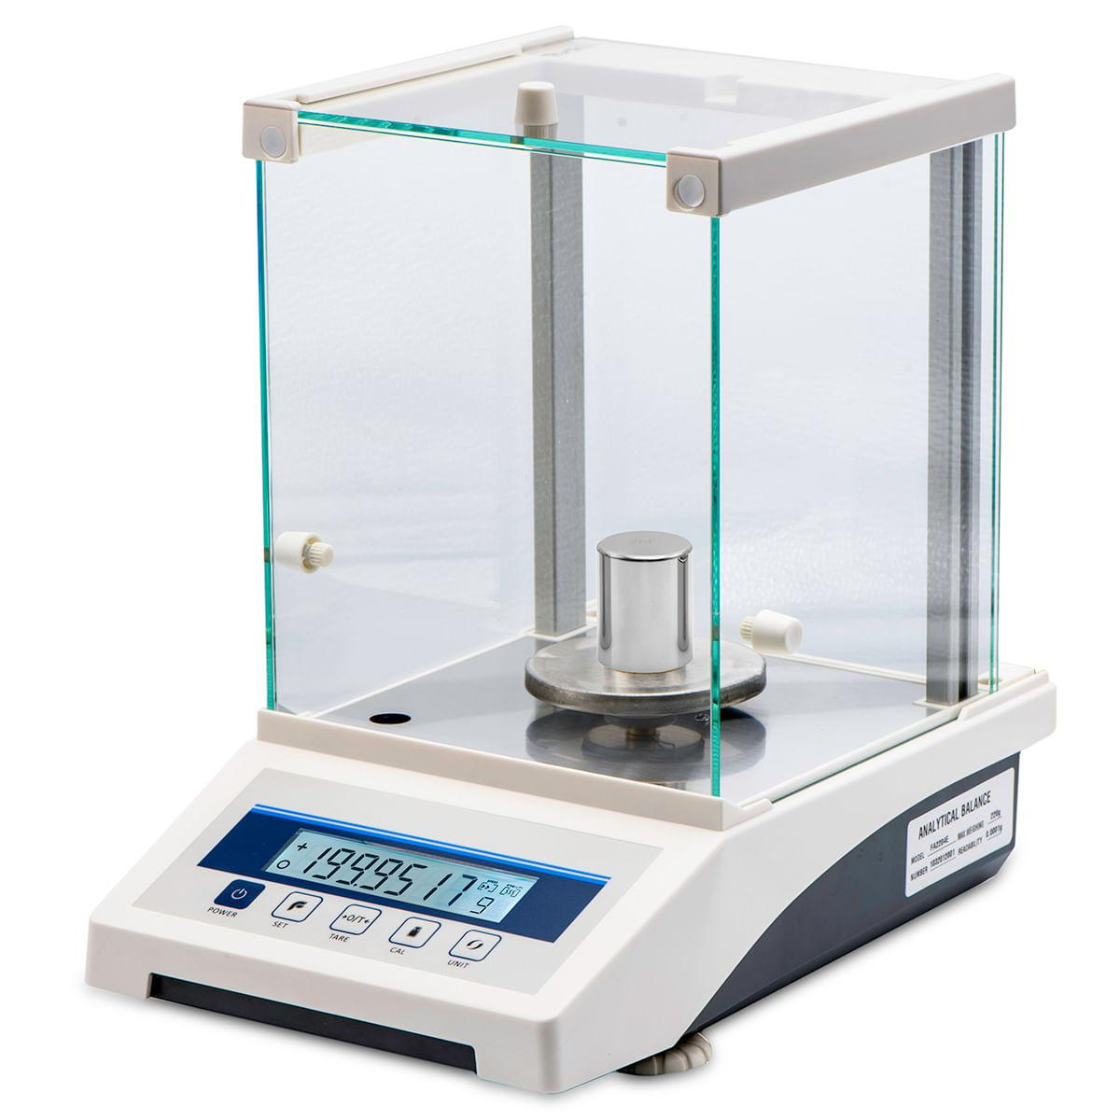
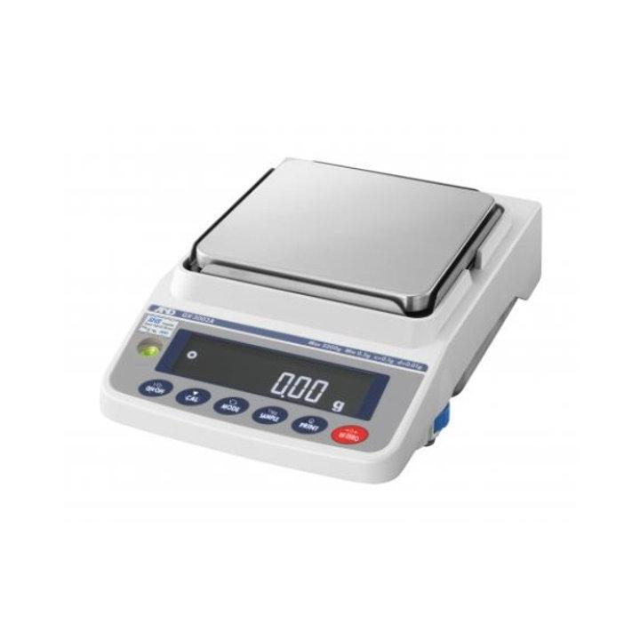
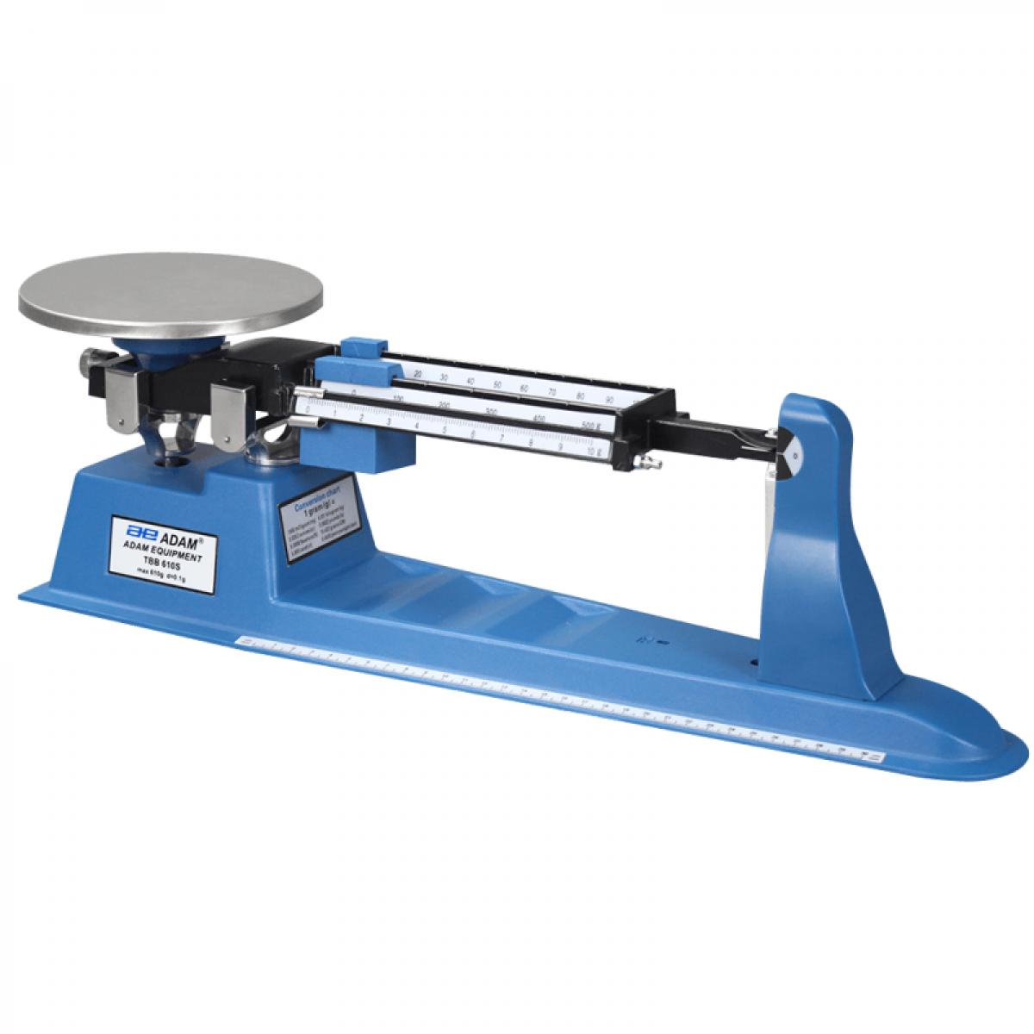
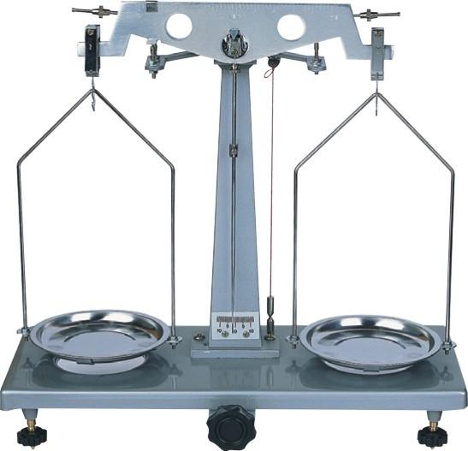
A Balance is a measuring instrument used to determine the mass of an object by comparing it with known reference masses or by using electronic sensing technology. Unlike a spring scale, which measures weight (force due to gravity), a balance is primarily designed to measure mass.
Balances are widely used in laboratories, education, manufacturing, pharmacies, jewelry, quality control, research, and industry.

Definition
# Source: AI Source: Provided by: [Data Path: Persons Table -> ID Column: 1, Name_En Column: Motasem Essam] -> From: [ChatGPT] on [7/17/2026]
A Balance is a measuring instrument used to determine the mass of an object by comparing it with standard masses or by electronically sensing the force required to balance the object.

Purpose
# Source: AI Source: Provided by: [Data Path: Persons Table -> ID Column: 1, Name_En Column: Motasem Essam] -> From: [ChatGPT] on [7/17/2026]
A balance is used to:
- Measure mass.
- Compare masses.
- Prepare laboratory samples.
- Weigh chemicals.
- Measure raw materials.
- Perform quality inspection.
- Support scientific experiments.

Principle of Operation
# Source: AI Source: Provided by: [Data Path: Persons Table -> ID Column: 1, Name_En Column: Motasem Essam] -> From: [ChatGPT] on [7/17/2026]
The operating principle depends on the type of balance:
- Mechanical balances compare the unknown mass with known standard masses.
- Electronic balances use load cells or electromagnetic force restoration to determine mass and display it digitally.

Main Components
# Source: AI Source: Provided by: [Data Path: Persons Table -> ID Column: 1, Name_En Column: Motasem Essam] -> From: [ChatGPT] on [7/17/2026]
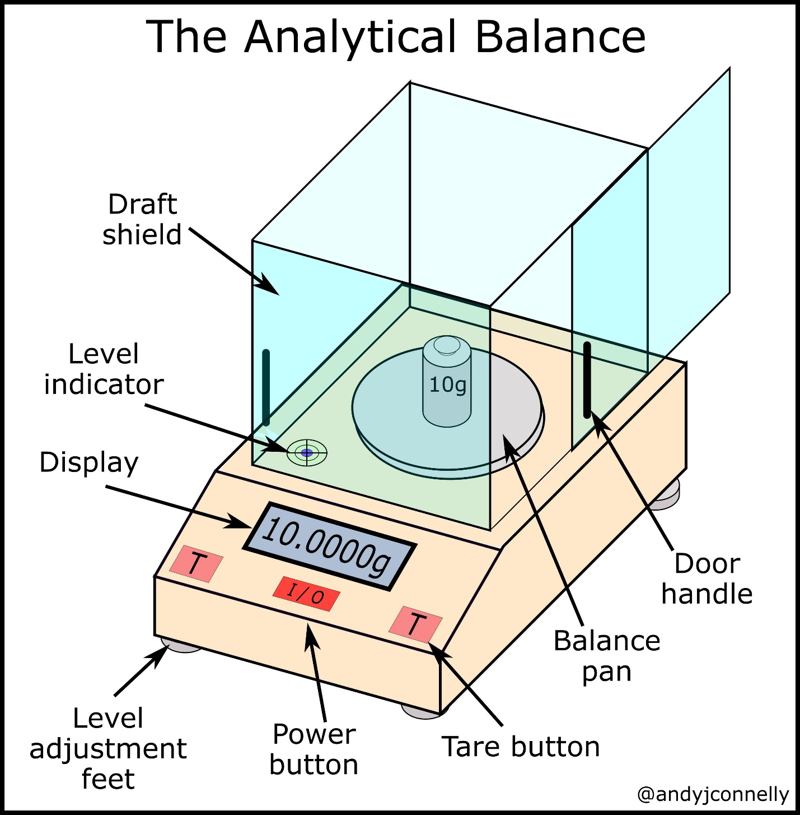
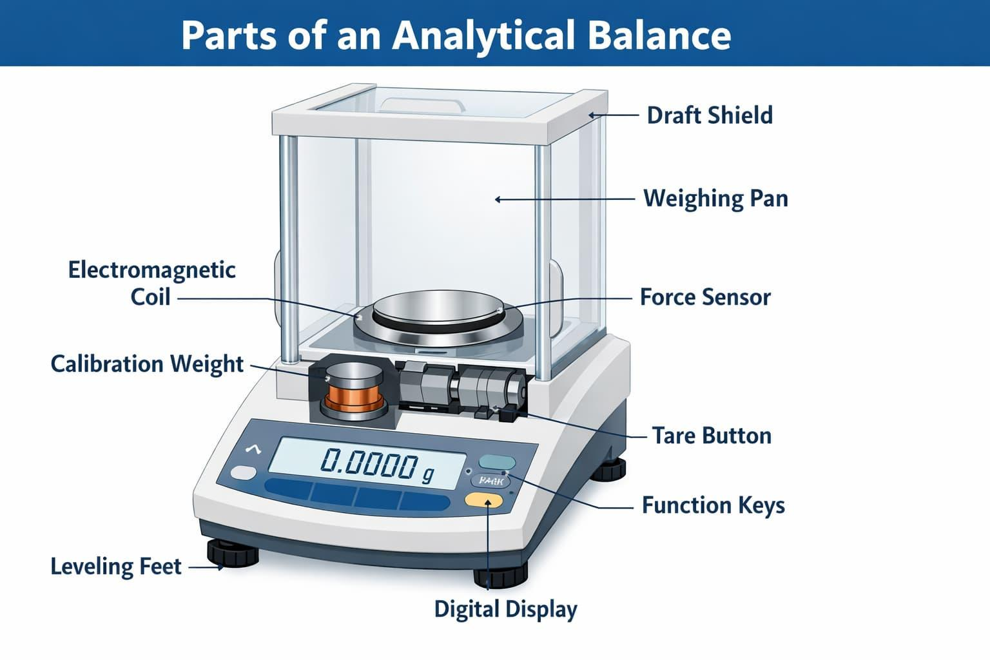
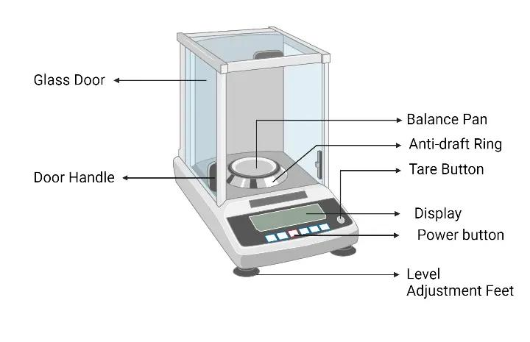
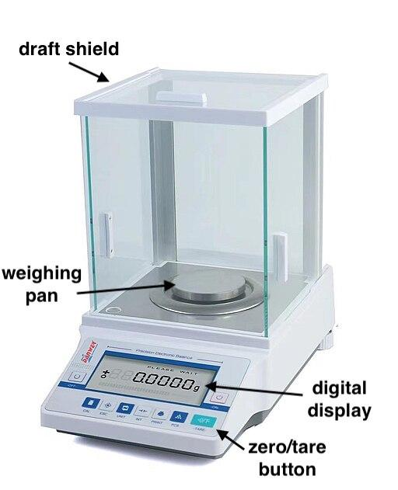
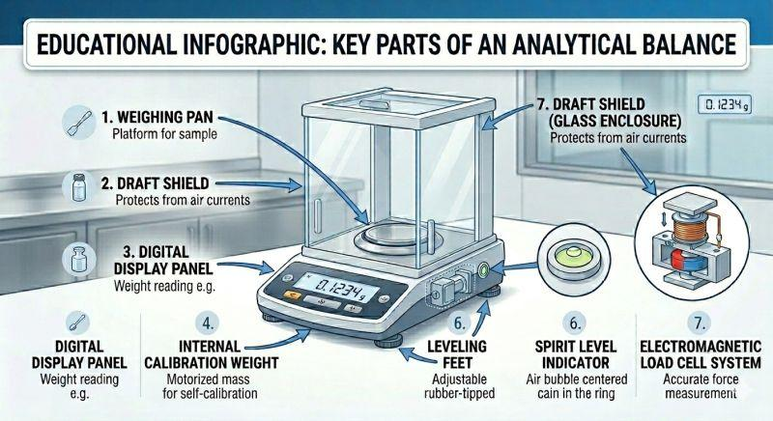
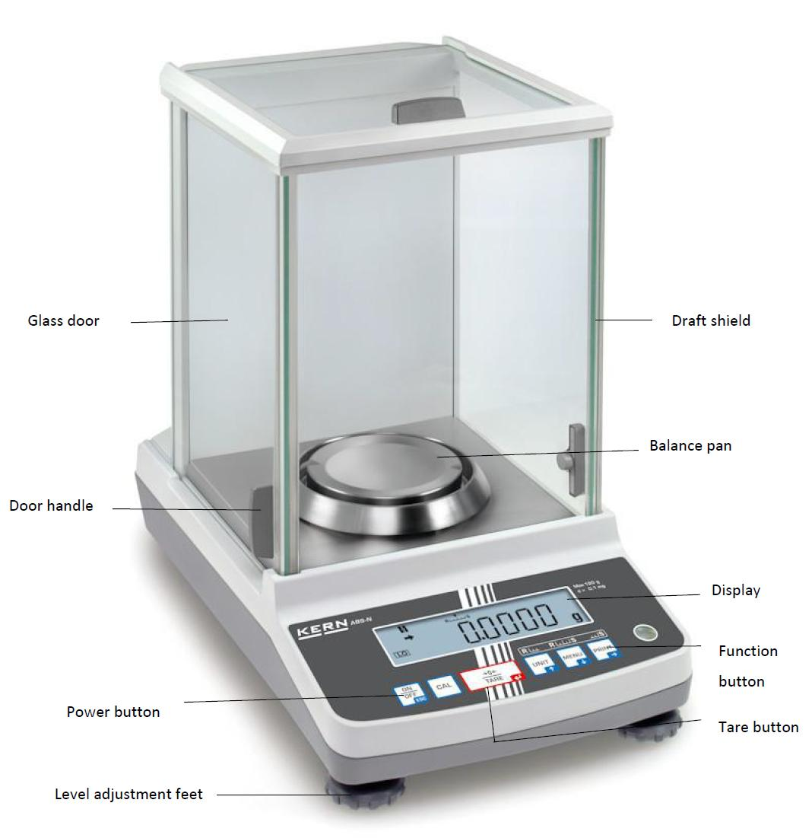
Typical components include:
- Weighing pan
- Base
- Measuring mechanism (beam, load cell, or electromagnetic sensor)
- Display or scale
- Control buttons (electronic models)
- Draft shield (analytical balances)
- Leveling feet
- Bubble level

Types of Balances

1. Equal-Arm Balance
# Source: AI Source: Provided by: [Data Path: Persons Table -> ID Column: 1, Name_En Column: Motasem Essam] -> From: [ChatGPT] on [7/17/2026]
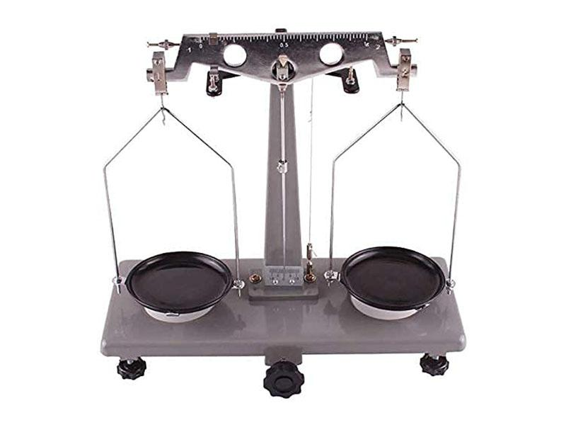
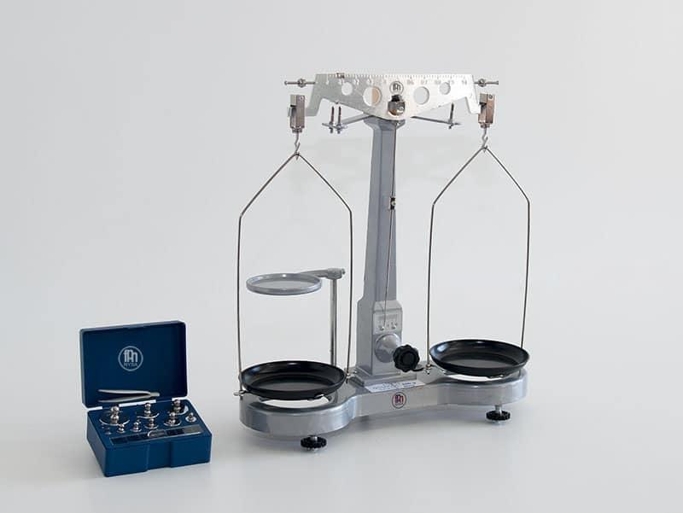
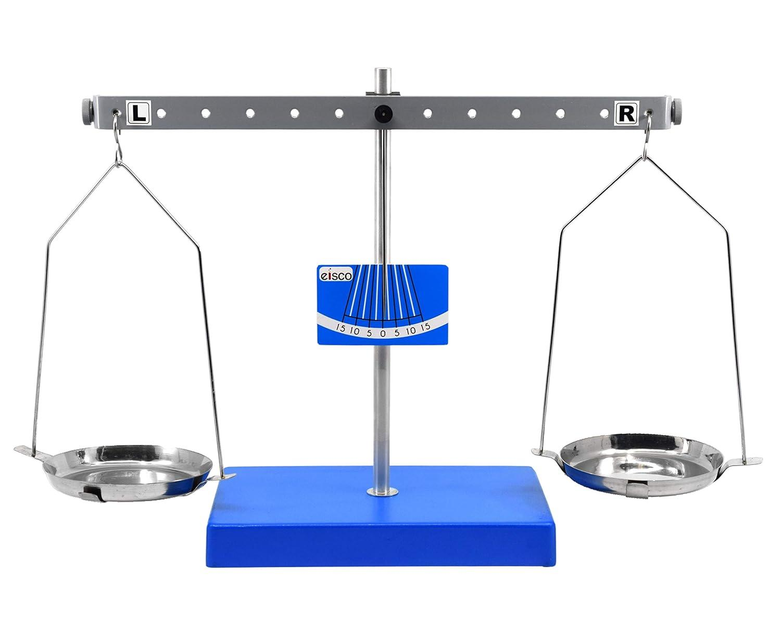
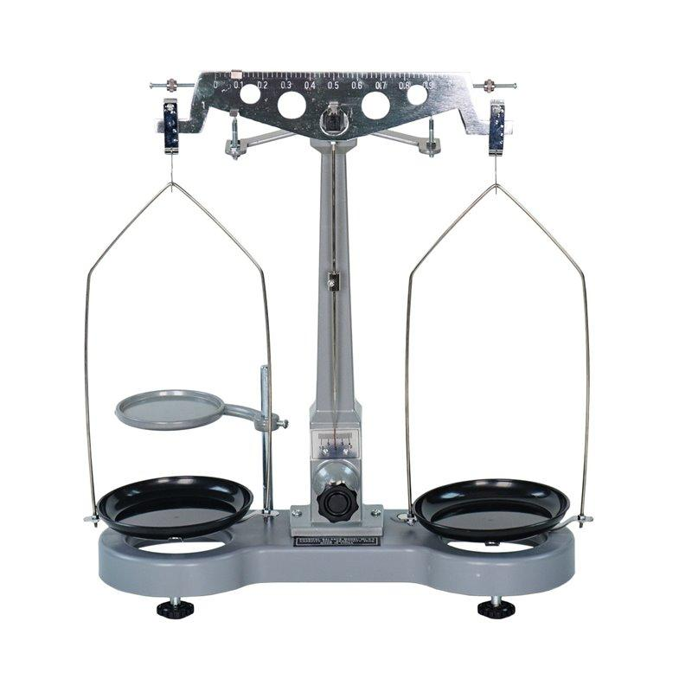
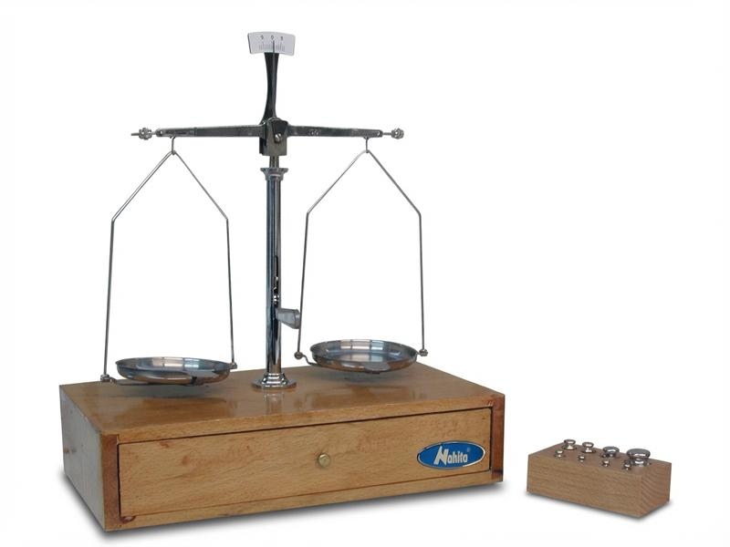
Description
A traditional mechanical balance with two pans that compares an unknown mass against standard weights.
Applications
- Educational laboratories
- Physics demonstrations
- Historical scientific work

2. Triple Beam Balance
# Source: AI Source: Provided by: [Data Path: Persons Table -> ID Column: 1, Name_En Column: Motasem Essam] -> From: [ChatGPT] on [7/17/2026]
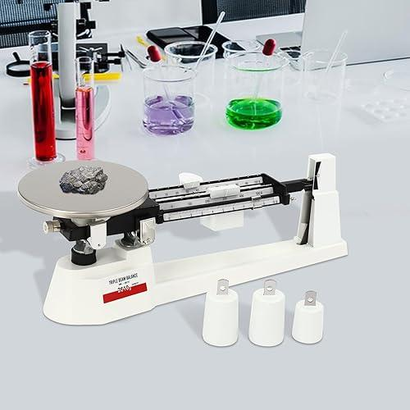
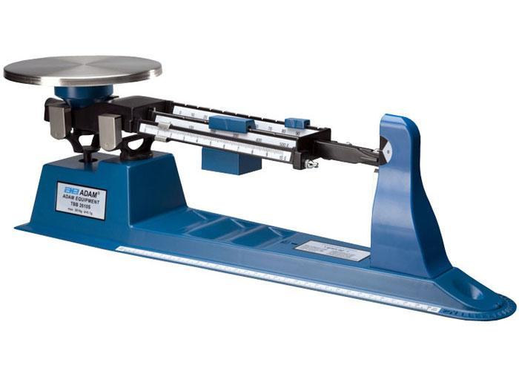
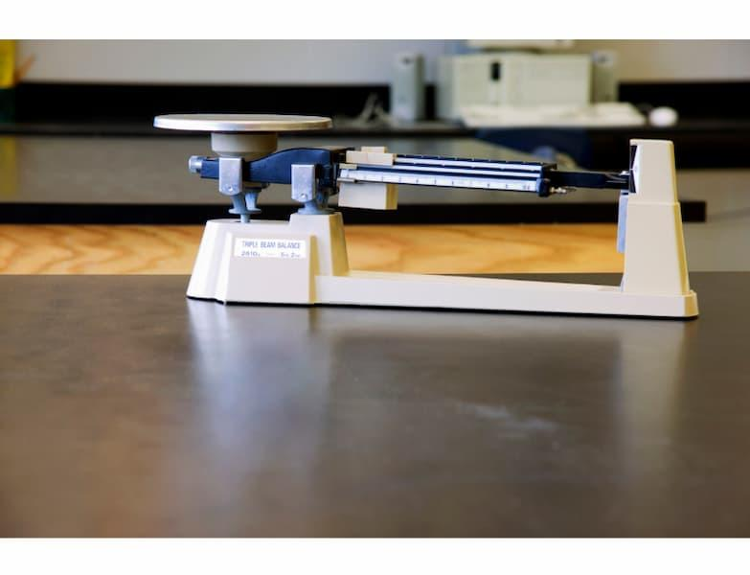
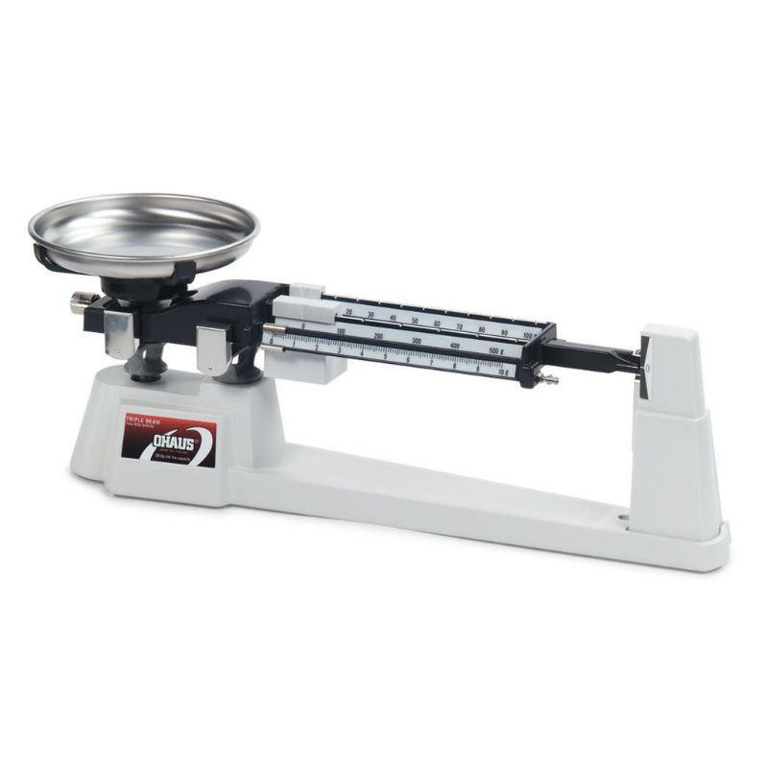
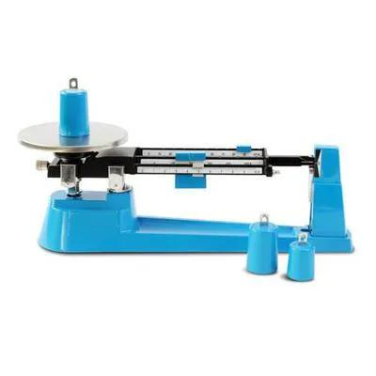
Description
A mechanical balance that uses three graduated beams with sliding riders to determine mass.
Typical Resolution
- 0.1 g
Applications
- School laboratories
- Educational experiments

3. Top-Loading (Precision) Electronic Balance
# Source: AI Source: Provided by: [Data Path: Persons Table -> ID Column: 1, Name_En Column: Motasem Essam] -> From: [ChatGPT] on [7/17/2026]
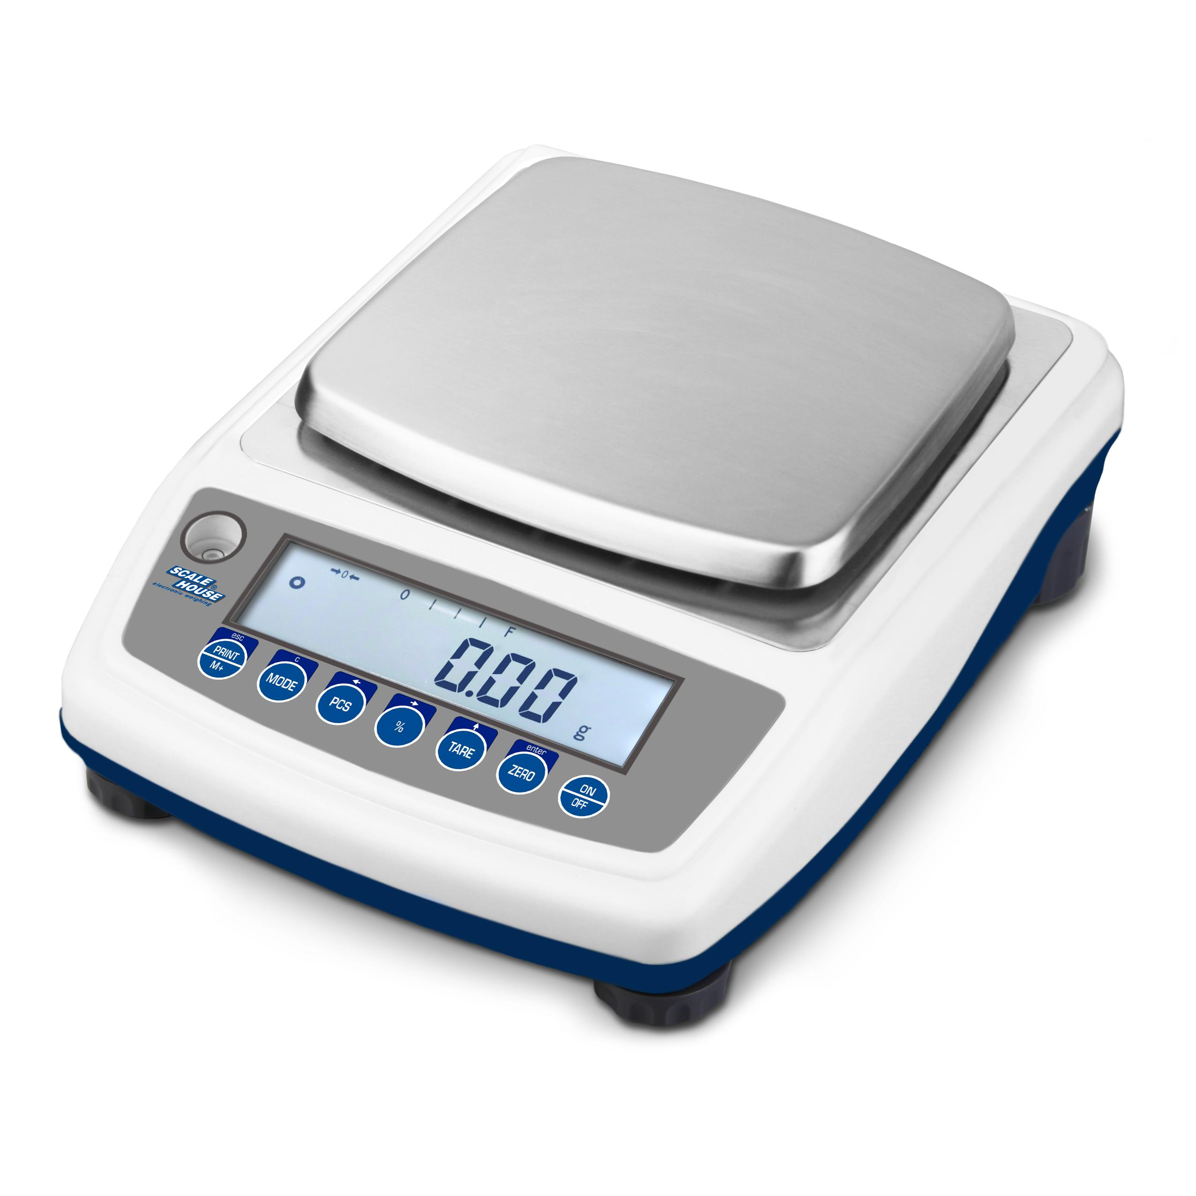
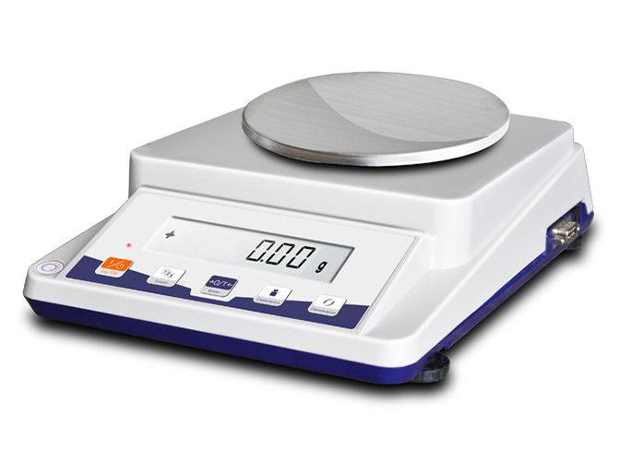
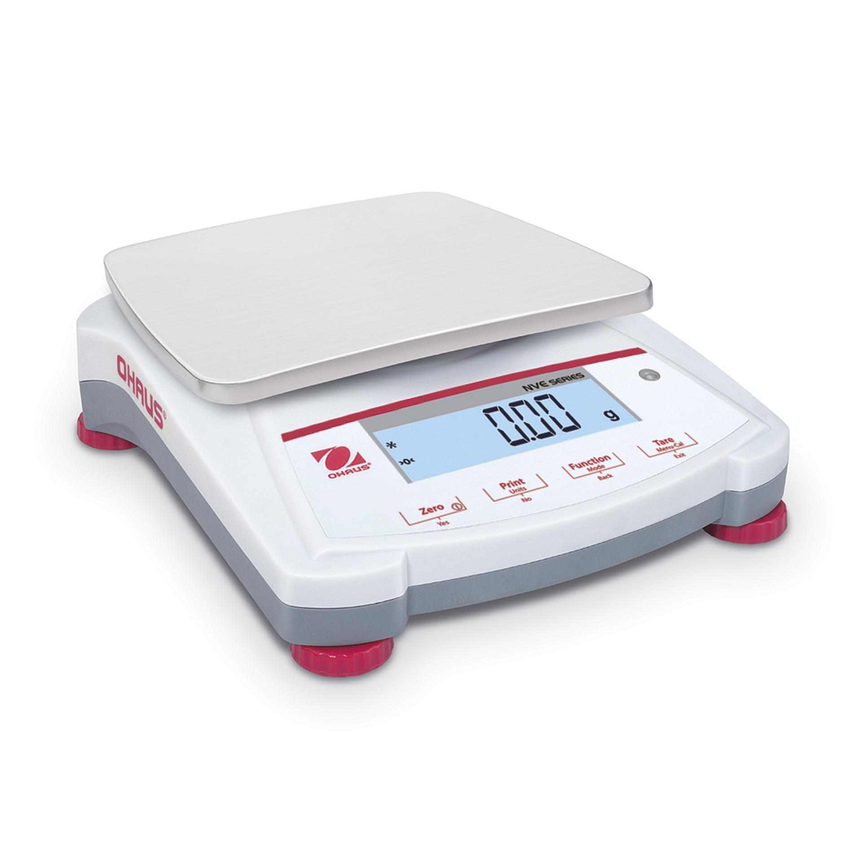
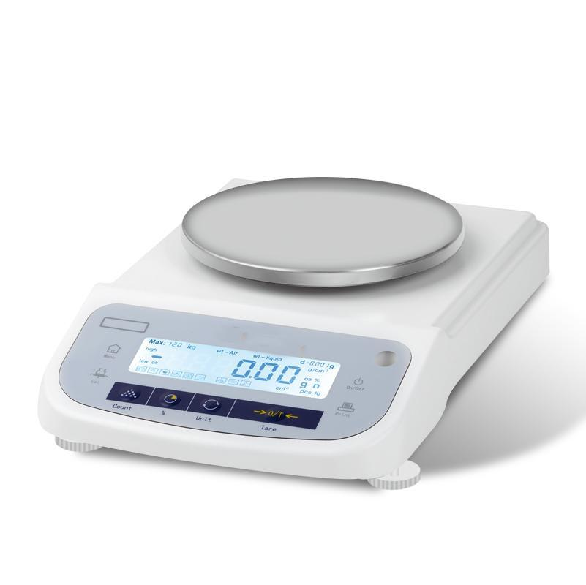
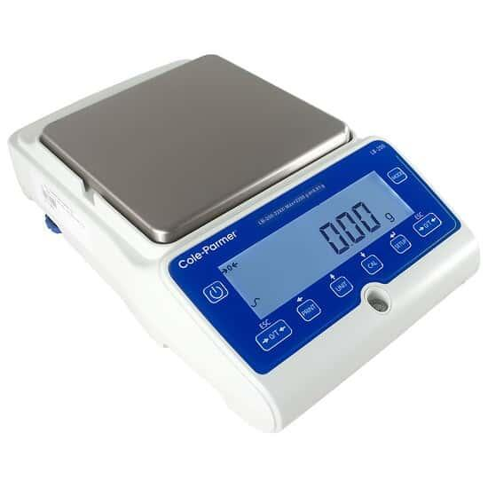
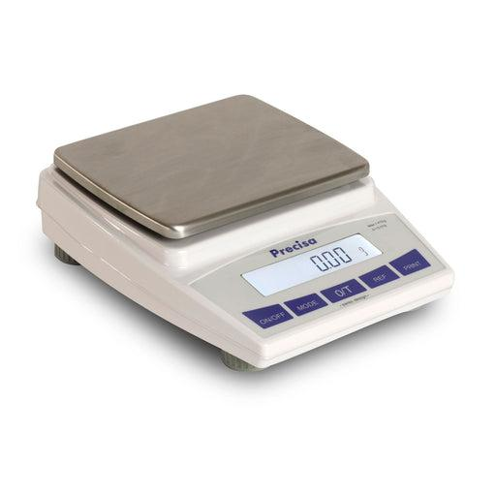
Description
A digital balance designed for accurate routine weighing of laboratory samples.
Features
- LCD display
- Fast readings
- Tare function
- Multiple weighing units
Applications
- Laboratories
- Manufacturing
- Quality control

4. Analytical Balance
# Source: AI Source: Provided by: [Data Path: Persons Table -> ID Column: 1, Name_En Column: Motasem Essam] -> From: [ChatGPT] on [7/17/2026]
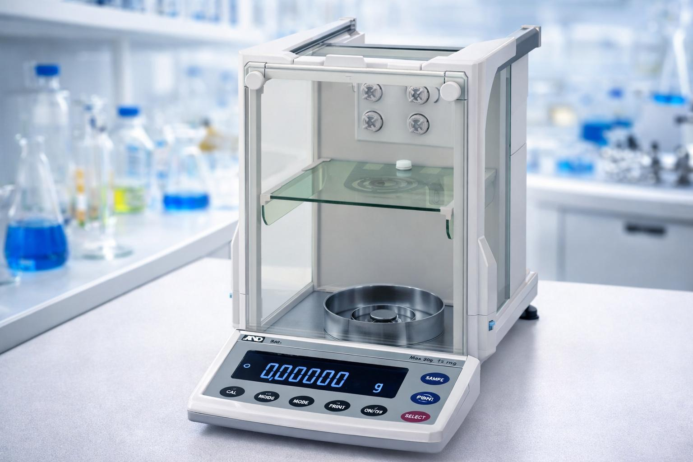
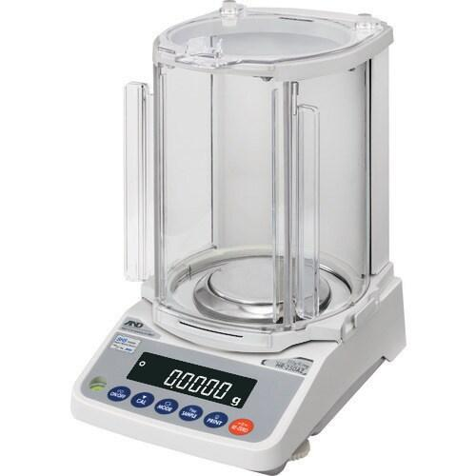
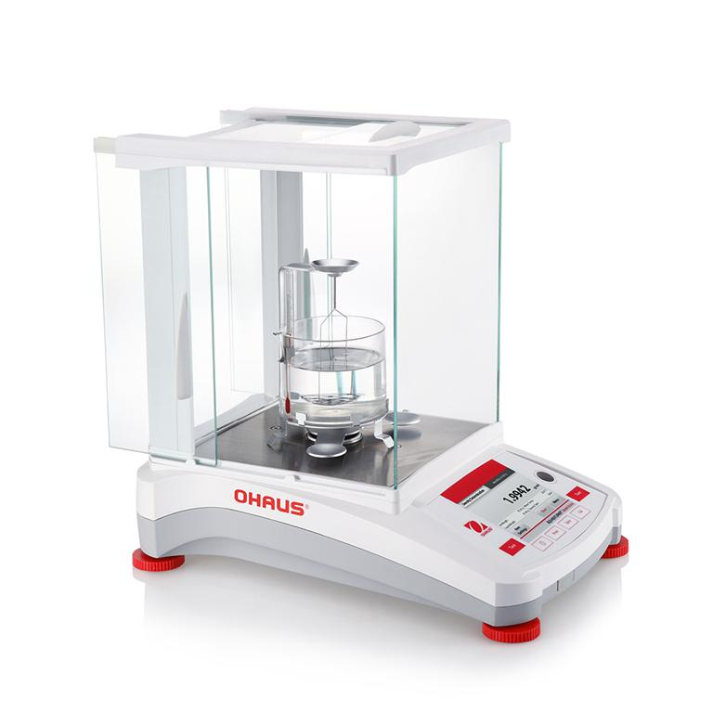
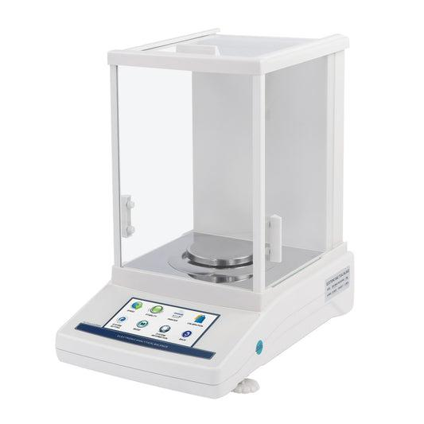
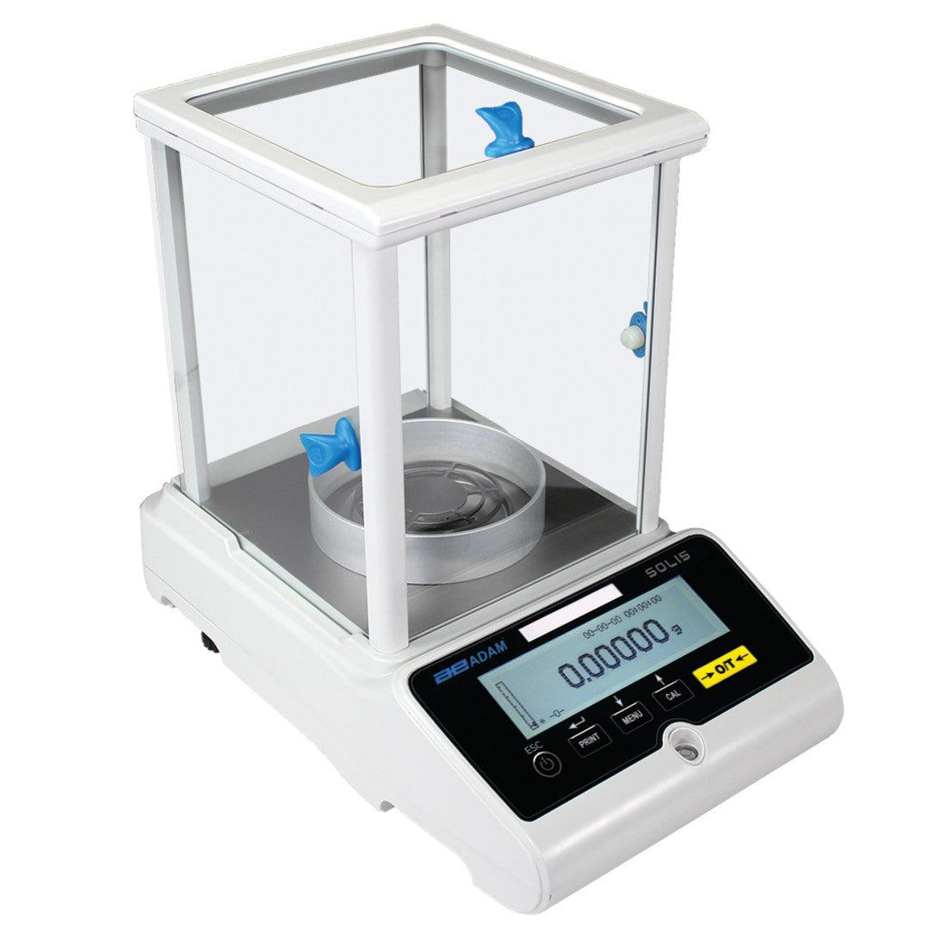
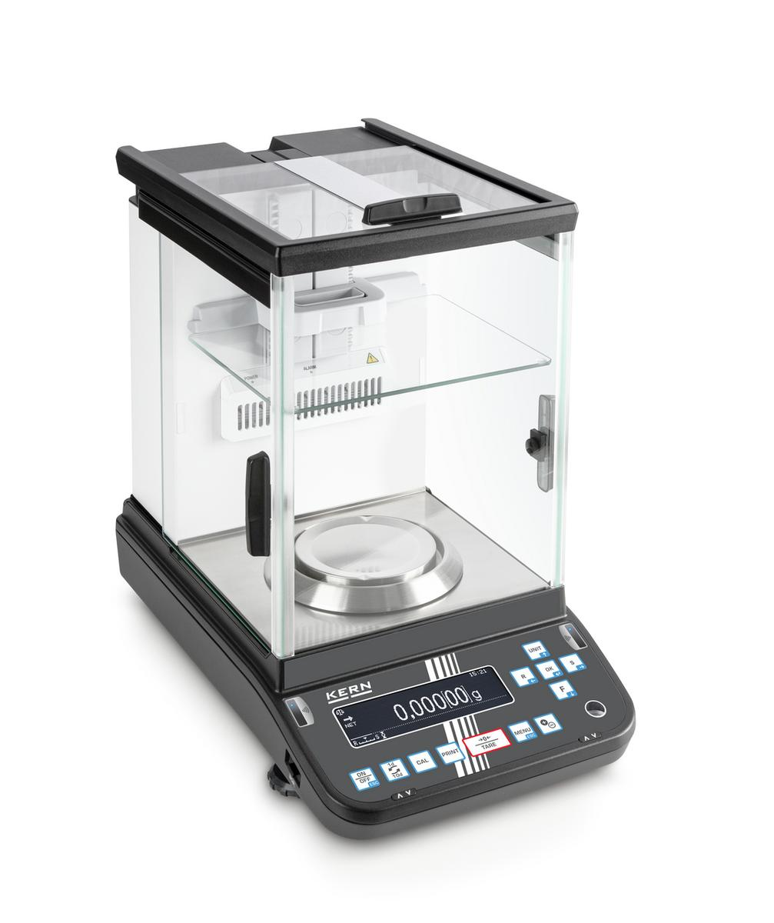
Description
A highly precise laboratory balance enclosed in a draft shield to eliminate air movement.
Features
- Extremely high precision
- Draft shield
- Electromagnetic measurement system
- Digital display
Typical Resolution
- 0.0001 g (0.1 mg)
Applications
- Chemistry
- Pharmaceuticals
- Scientific research
- Calibration laboratories

5. Microbalance
# Source: AI Source: Provided by: [Data Path: Persons Table -> ID Column: 1, Name_En Column: Motasem Essam] -> From: [ChatGPT] on [7/17/2026]
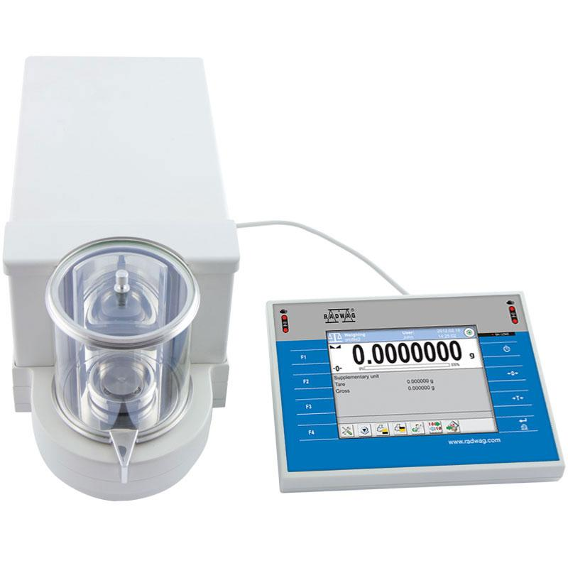
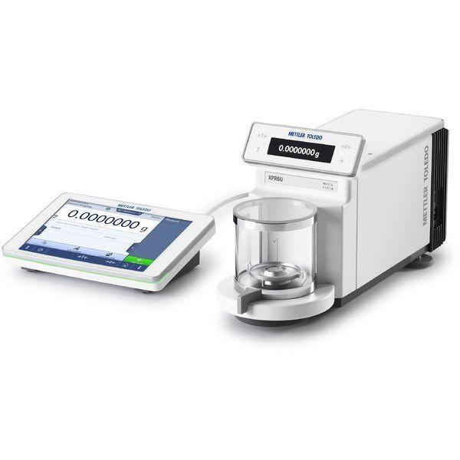
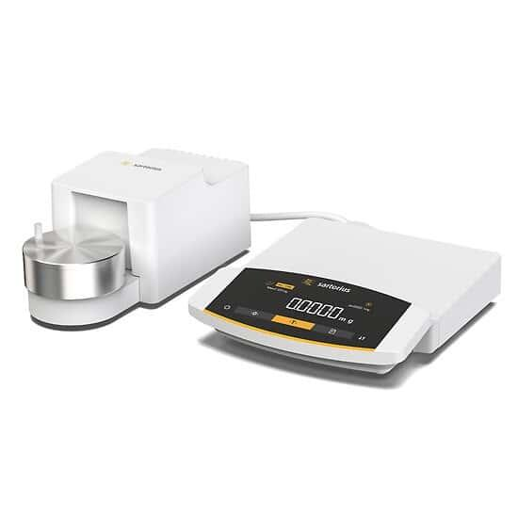
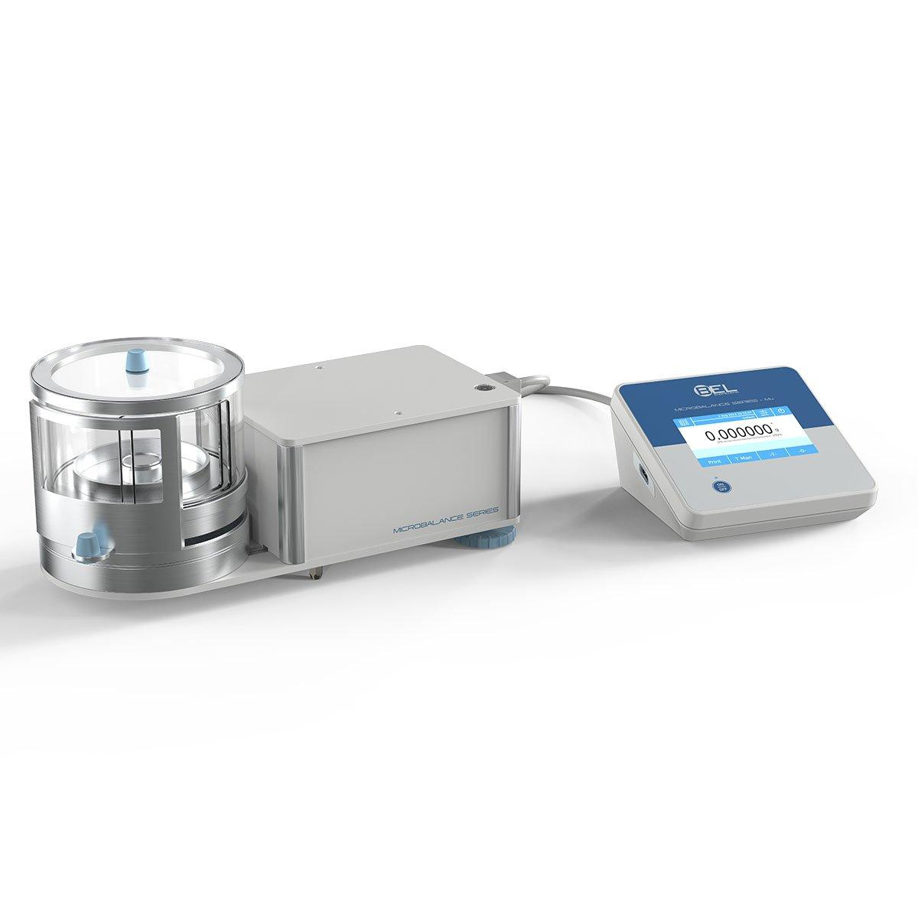
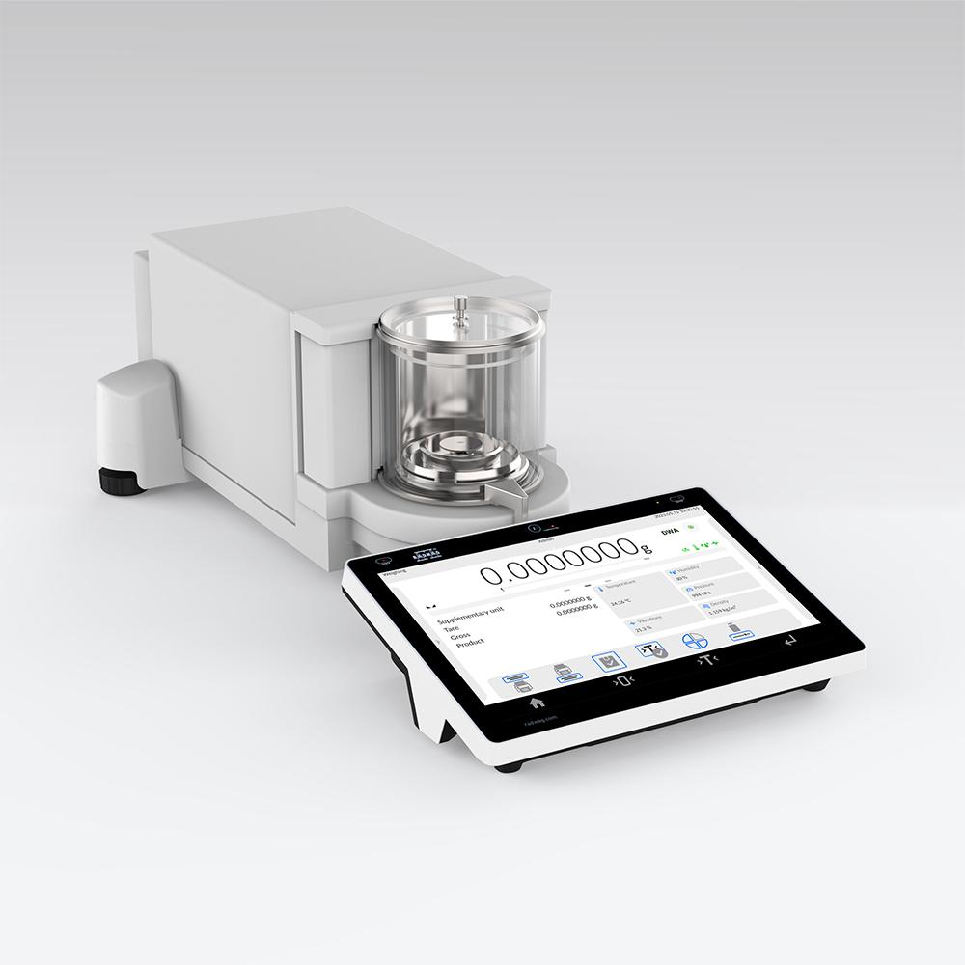
Description
A balance capable of measuring extremely small masses.
Typical Resolution
- 0.000001 g (1 µg)
Applications
- Nanotechnology
- Material science
- Advanced research

Measuring Units
# Source: AI Source: Provided by: [Data Path: Persons Table -> ID Column: 1, Name_En Column: Motasem Essam] -> From: [ChatGPT] on [7/17/2026]
Balances commonly display:
- Gram (g)
- Kilogram (kg)
- Milligram (mg)
- Microgram (µg)
- Ounce (oz)
- Pound (lb)

Measuring Range
# Source: AI Source: Provided by: [Data Path: Persons Table -> ID Column: 1, Name_En Column: Motasem Essam] -> From: [ChatGPT] on [7/17/2026]
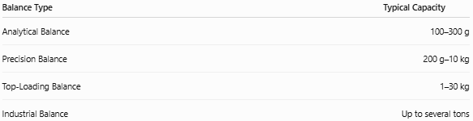
Balance Type | Typical Capacity
Analytical Balance | 100–300 g
Precision Balance | 200 g–10 kg
Top-Loading Balance | 1–30 kg
Industrial Balance | Up to several tons

Resolution
# Source: AI Source: Provided by: [Data Path: Persons Table -> ID Column: 1, Name_En Column: Motasem Essam] -> From: [ChatGPT] on [7/17/2026]
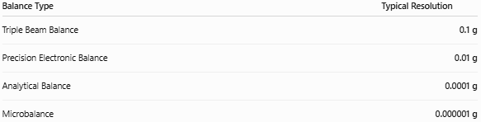
Balance Type | Typical Resolution
Triple Beam Balance | 0.1 g
Precision Electronic Balance | 0.01 g
Analytical Balance | 0.0001 g
Microbalance | 0.000001 g

How to Measure Mass with a Balance
# Source: AI Source: Provided by: [Data Path: Persons Table -> ID Column: 1, Name_En Column: Motasem Essam] -> From: [ChatGPT] on [7/17/2026]
- Place the balance on a stable, level surface.
- Turn it on (electronic models).
- Allow it to stabilize.
- Press Tare if using a container.
- Place the object on the weighing pan.
- Wait for the reading to stabilize.
- Record the measured mass.

Example
# Source: AI Source: Provided by: [Data Path: Persons Table -> ID Column: 1, Name_En Column: Motasem Essam] -> From: [ChatGPT] on [7/17/2026]
Suppose an analytical balance displays:
25.6843 g
The measured mass is:
- 25.6843 g
- 0.0256843 kg
- 25,684.3 mg

Accuracy
# Source: AI Source: Provided by: [Data Path: Persons Table -> ID Column: 1, Name_En Column: Motasem Essam] -> From: [ChatGPT] on [7/17/2026]
Typical accuracy depends on:
- Instrument type
- Calibration
- Environmental conditions
- Load capacity
Analytical balances can achieve accuracies of ±0.0002 g or better.

Sources of Error
# Source: AI Source: Provided by: [Data Path: Persons Table -> ID Column: 1, Name_En Column: Motasem Essam] -> From: [ChatGPT] on [7/17/2026]
Instrument Errors
- Calibration drift
- Damaged load cell
- Mechanical wear
- Electronic faults

Observation Errors
- Reading before stabilization
- Recording errors
- Incorrect unit selection

Positioning Errors
- Object not centered on the pan
- Overloading the balance
- Improper tare operation

Environmental Errors
- Air currents
- Temperature changes
- Vibrations
- Static electricity
- Dust and moisture

Applications
# Source: AI Source: Provided by: [Data Path: Persons Table -> ID Column: 1, Name_En Column: Motasem Essam] -> From: [ChatGPT] on [7/17/2026]
Balances are used in:
- Chemistry laboratories
- Pharmaceutical production
- Food industry
- Jewelry
- Manufacturing
- Quality control
- Research laboratories
- Educational institutions
- Medical laboratories

Advantages
# Source: AI Source: Provided by: [Data Path: Persons Table -> ID Column: 1, Name_En Column: Motasem Essam] -> From: [ChatGPT] on [7/17/2026]
A balance:
- Provides accurate mass measurements.
- Offers high precision.
- Supports multiple weighing units.
- Includes tare functions (electronic models).
- Can measure from grams to micrograms, depending on the type.

Limitations
# Source: AI Source: Provided by: [Data Path: Persons Table -> ID Column: 1, Name_En Column: Motasem Essam] -> From: [ChatGPT] on [7/17/2026]
A balance:
- May require frequent calibration.
- Is sensitive to vibration and air movement.
- Analytical balances require controlled laboratory conditions.
- Precision decreases if overloaded.

Comparison with Other Mass and Weight Measuring Instruments
# Source: AI Source: Provided by: [Data Path: Persons Table -> ID Column: 1, Name_En Column: Motasem Essam] -> From: [ChatGPT] on [7/17/2026]
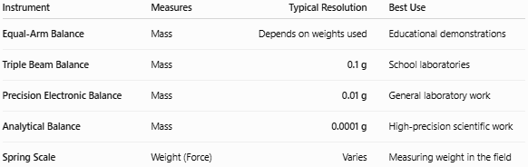
Instrument | Measures | Typical Resolution | Best Use
Equal-Arm Balance | Mass | Depends on weights used | Educational demonstrations
Triple Beam Balance | Mass | 0.1 g | School laboratories
Precision Electronic Balance | Mass | 0.01 g | General laboratory work
Analytical Balance | Mass | 0.0001 g | High-precision scientific work
Spring Scale | Weight (Force) | Varies | Measuring weight in the field

Care and Maintenance
# Source: AI Source: Provided by: [Data Path: Persons Table -> ID Column: 1, Name_En Column: Motasem Essam] -> From: [ChatGPT] on [7/17/2026]
To maintain accuracy:
- Keep the weighing pan clean.
- Avoid overloading.
- Calibrate regularly.
- Protect from vibration and drafts.
- Store in a clean, dry environment.
- Use the draft shield when required.

Common Mistakes
# Source: AI Source: Provided by: [Data Path: Persons Table -> ID Column: 1, Name_En Column: Motasem Essam] -> From: [ChatGPT] on [7/17/2026]
- Confusing mass with weight.
- Forgetting to use the tare function.
- Weighing hot or cold samples before they reach room temperature.
- Touching samples with bare hands, adding contamination.
- Using an analytical balance in a drafty environment.

Key Points
# Source: AI Source: Provided by: [Data Path: Persons Table -> ID Column: 1, Name_En Column: Motasem Essam] -> From: [ChatGPT] on [7/17/2026]
- A Balance measures mass, not weight.
- Common types:
  - Equal-Arm Balance
  - Triple Beam Balance
  - Precision Electronic Balance
  - Analytical Balance
  - Microbalance
- Analytical balances commonly have a resolution of 0.0001 g.
- Balances are essential in laboratories, manufacturing, pharmaceuticals, education, and quality control.

Conclusion
# Source: AI Source: Provided by: [Data Path: Persons Table -> ID Column: 1, Name_En Column: Motasem Essam] -> From: [ChatGPT] on [7/17/2026]
A Balance is one of the most important instruments for measuring mass with accuracy and precision. From simple mechanical balances used in education to highly sensitive analytical and microbalances used in scientific research, these instruments support reliable measurements across a wide range of industries. Selecting the appropriate type of balance depends on the required capacity, resolution, and accuracy, as well as the environmental conditions in which the measurements are performed.

